**Laporan Praktikum**

COMPUTER NETWORK

MATA KULIAH COMP6372004 - Computer Networks

KELAS BC20

Oleh :

Audric Nagata-2602090435

Semester Ganjil, 2023/2024 MALANG

SOAL SESI 1

You are asked to give each device an IP address based on the picture below. Open the given 01.pka file and follow the instruction given.

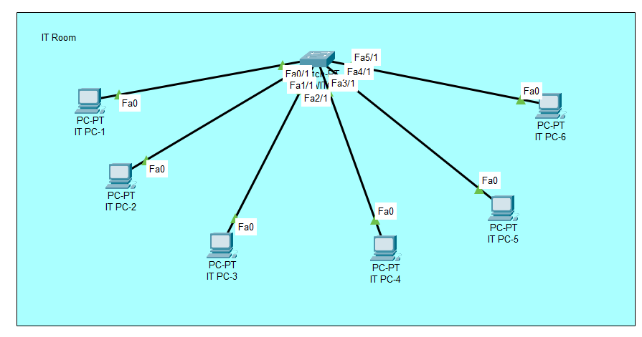

Rules that need to be satisfied:

1. Network address that will be used is 192.168.0.0/24
2. IP assigned to the gateway must be the first usable IP of the network
3. IP assigned to the host is depends on the PC's name, for example:
   * PC-1 always use the second usable IP in the subnet
   * PC-2 always use the third usable IP in the subnet
   * ...
   * PC-Last always use the last usable IP in the subnet

Gateway : 192.168.0.1

IT PC-1 : 192.168.0.2

IT PC-2 : 192.168.0.3

IT PC-3 : 192.168.0.4

IT PC-4 : 192.168.0.5

IT PC-5 : 192.168.0.6

IT PC-6 : 192.168.0.7

SOAL SESI 2

Quantum & Clock is a new startup company that recently moved to a new building. Therefore, they will need a new computer network in the new building. There will be 4 rooms in the building each with its network. Those networks will be under the main network which network address is 192.168.36.0/24. The details of each room will be written below,

* Staffroom – 68 computers
* IT room – 27 computers
* Designer room – 33 computers
* Operational room – 12 computers

With the room details already explained above, the CEO of Quantum & Clock wanted you to do the following task,

1. Create a new subnet mask for every network above using FLSM and VLSM.
2. Open the .pka file and follow the instruction written inside the file to create a LAN connection. Make sure that each device can connect.

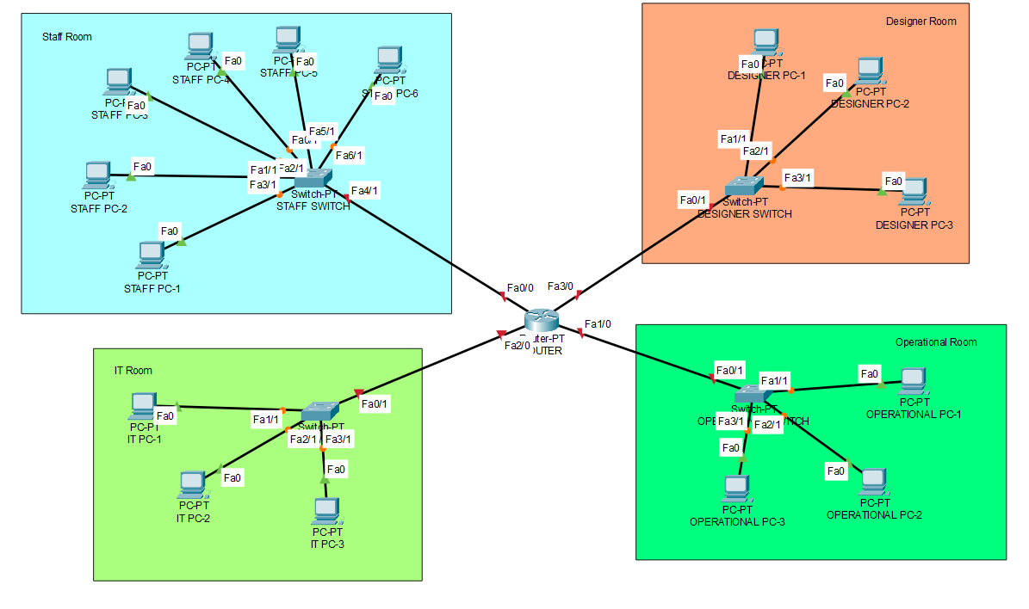

After you do subnetting, now you need to assign IP address for each PC using your subnetting result with following criteria:

* **First range IP address** must be used for **Staff division**
* **Second range IP address** must be used for **Designer division**
* **Third range IP address** must be used for **IT division**
* **Fourth range IP address** must be used for **Operational division**
* Make sure every PC is connected to each other.

Rules that need to be satisfied:

1. IP assigned to the gateway must be the first usable IP of the network
2. IP assigned to the host is depends on the PC's name, for example:
   * PC-1 always use the second usable IP in the subnet
   * PC-2 always use the third usable IP in the subnet
   * ...
   * PC-Last always use the last usable IP in the subnet

(FLSM)

1. Router
   1. Fa0/0 : 192.168.36.1
   2. Fa1/0 : 192.168.37.129
   3. Fa2/0 : 192.168.37.1
   4. Fa3/0 : 192.168.36.129
2. Staffroom – 68 computers
   1. 255.255.255.128 /25 : Subnet
   2. 192.168.36.0 : Network ID
   3. 192.168.36.1 : Gateway
   4. 192.168.36.(2 - 126) : Host
   5. 192.168.36.127 : Broadcast ID
3. Designer room – 33 computers
   1. 255.255.255.128 /25 : Subnet
   2. 192.168.36.128 : Network ID
   3. 192.168.36.129 : Gateway
   4. 192.168.36.(130 - 254) : Host
   5. 192.168.36.255 : Broadcast ID
4. IT room – 27 computers
   1. 255.255.255.128 /25 : Subnet
   2. 192.168.37.0 : Network ID
   3. 192.168.37.1 : Gateway
   4. 192.168.37.(2 - 126) : Host
   5. 192.168.37.127 : Broadcast ID
5. Operational room – 12 computers
   1. 255.255.255.128 /25 : Subnet
   2. 192.168.37.128 : Network ID
   3. 192.168.37.129 : Gateway
   4. 192.168.37.(130 - 254) : Host
   5. 192.168.37.255 : Broadcast ID
6. (VLSM)
7. Router
   1. Fa0/0 : 192.168.36.1
   2. Fa1/0 : 192.168.36.225
   3. Fa2/0 : 192.168.36.193
   4. Fa3/0 : 192.168.36.129
8. Staffroom – 68 computers
   1. 255.255.255.128 /25 : Subnet
   2. 192.168.36.0 : Network ID
   3. 192.168.36.1 : Gateway
   4. 192.168.36.(2 - 126) : Host
   5. 192.168.36.127 : Broadcast ID
9. Designer room – 33 computers
   1. 255.255.255.192 /26 : Subnet
   2. 192.168.36.128 : Network ID
   3. 192.168.36.129 : Gateway
   4. 192.168.36.(130 - 190) : Host
   5. 192.168.36.191 : Broadcast ID
10. IT room – 27 computers
    1. 255.255.255.224 /27 : Subnet
    2. 192.168.36.192 : Network ID
    3. 192.168.36.193 : Gateway
    4. 192.168.36.(194 - 222) : Host
    5. 192.168.26.223 : Broadcast ID
11. Operational room – 12 computers
    1. 255.255.255.240 /28 : Subnet
    2. 192.168.36.224 : Network ID
    3. 192.168.36.225 : Gateway
    4. 192.168.36.(226 - 238) : Host
    5. 192.168.36.239 : Broadcast ID

SOAL SESI 3

Quantum & Clock has become bigger and currently building a two-floor office. Each floor will have a router for rooms inside that floor. Quantum & Clock wanted all devices inside the network to be able to communicate with each other. Therefore, you as a network engineer is asked to make static routing for the network based on the network below,

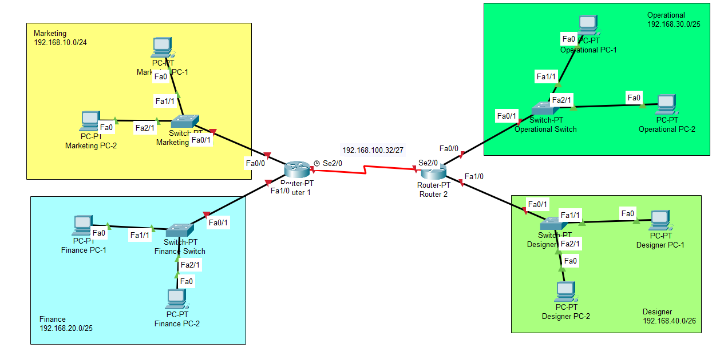

You are asked to:

1. Assign IP address for every device
2. Use static routing to connect every network, make sure every pc is connected to each other

Rules that need to be satisfied:

1. IP assigned to gateway must be the first usable IP of the network
2. IP assigned to connect 2 routers is determined based on router position (left to right):
   * First usable IP address of the network is used for the first router (leftmost)
   * Second usable IP address of the network is used for the second router (rightmost)

Example: if the network is 192.168.12.0/24, then:

* + IP address for the first router is 192.168.12.1
  + IP address for the second router is 192.168.12.2

1. IP assigned to the host is depends on the PC's name, for example:
   * PC/Laptop-1 always use the second usable IP in the subnet
   * PC/Laptop-2 always use the third usable IP in the subnet
   * ...
   * PC/Laptop-Last always use the last usable IP in the subnet
2. Router 1
   1. Se2/0 : 192.168.100.33
   2. Fa0/0 : 192.168.10.1
   3. Fa1/0 : 192.168.20.1

Static Routes :

* 1. 192.168.30.0/25 via 192.168.100.34
  2. 192.168.40.0/25 via 192.168.100.34
  3. 192.168.50.0/26 via 192.168.100.34

1. Router 2
   1. Se2/0 : 192.168.100.34
   2. Se3/0 : 192.168.100.129
   3. Fa0/0 : 192.168.30.1

Static Routes :

* 1. 192.168.10.0/24 via 192.168.100.33
  2. 192.168.20.0/25 via 192.168.100.33
  3. 192.168.40.0/25 via 192.168.100.130
  4. 192.168.50.0/26 via 192.168.100.130

1. Router 3
   1. Se2/0 : 192.168.100.130
   2. Fa0/0 : 192.168.40.1
   3. Fa1/0 : 192.168.50.1

Static Routes :

* 1. 192.168.10.0/24 via 192.168.100.129
  2. 192.168.20.0/25 via 192.168.100.129
  3. 192.168.30.0/25 via 192.168.100.129

1. Marketing : 192.168.10.0/24
   1. IP PC-1 : 192.168.10.2
   2. IP PC-2 : 192.168.10.3
   3. Subnet : 255.255.255.0
   4. Gateway : 192.168.10.1
2. Finance : 192.168.20.0/25
   1. IP PC-1 : 192.168.20.2
   2. IP PC-2 : 192.168.20.3
   3. Subnet : 255.255.255.128
   4. Gateway : 192.168.20.1
3. Administrator : 192.168.30.0/25
   1. IP PC-1 : 192.168.30.2
   2. IP PC-2 : 192.168.30.3
   3. Subnet : 255.255.255.128
   4. Gateway : 192.168.30.1
4. Operational : 192.168.40.0/25
   1. IP PC-1 : 192.168.40.2
   2. IP PC-2 : 192.168.40.3
   3. Subnet : 255.255.255.128
   4. Gateway : 192.168.40.1
5. Designer : 192.168.50.0/26
   1. IP PC-1 : 192.168.50.2
   2. IP PC-2 : 192.168.50.3
   3. Subnet : 255.255.255.192
   4. Gateway : 192.168.50.1

SOAL SESI 4

After building a two-floor office and implementing static routing for that building, Quantum & Clock realized because all devices can communicate with each other. Therefore, the security of each division is significantly lower. So, you as a network engineer are asked to implement an access list inside the two-floor office. Below are the network topology asked by Quantum & Clock

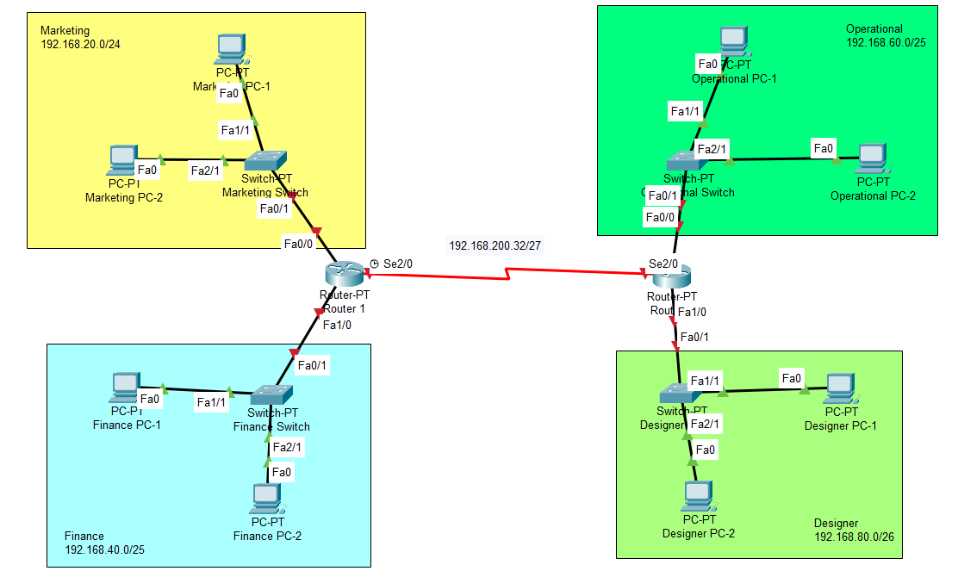

You are asked to:

1. Assign IP address for every device
2. Use static routing to connect every network, make sure every pc is connected to each other
3. Create an Extended Access List for **Inbound** traffic in **FastEthernet 0/0** on **Router 1**, so **Marketing PC-1** cannot receive and send packet data to **Administrator PC-2**, use 174 as your access list number
4. Create an Extended Access List for **Outbound** traffic in **FastEthernet 1/0** on **Router 3**, so **Finance PC-1** cannot receive and send packet data to **Designer PC-2**, use 178 as your access list number

Rules that need to be satisfied:

1. IP assigned to gateway must be the first usable IP of the network
2. IP assigned to connect 2 routers is determined based on router position (left to right):
   * First usable IP address of the network is used for the first router (leftmost)
   * Second usable IP address of the network is used for the second router (rightmost)

Example: if the network is 192.168.12.0/24, then:

* + IP address for the first router is 192.168.12.1
  + IP address for the second router is 192.168.12.2

1. IP assigned to the host is depends on the PC's name, for example:
   * PC/Laptop-1 always use the second usable IP in the subnet
   * PC/Laptop-2 always use the third usable IP in the subnet
   * ...
   * PC/Laptop-Last always use the last usable IP in the subnet
     1. Marketing : 192.168.10.0/24

PC-1 : 192.168.10.2

PC-2 : 192.168.10.3

Subnet : 255.255.255.0

Gateway : 192.168.10.1

* + 1. Finance 192.168.20.0/25

PC-1 : 192.168.20.2

PC-2 : 192.168.20.3

Subnet : 255.255.255.128

Gateway : 192.168.20.1

1. Administrator 192.168.30.0/25

PC-1 : 192.168.30.2

PC-2 : 192.168.30.3

Subnet : 255.255.255.128

Gateway : 192.168.30.1

1. Operational : 192.168.40.0/25

PC-1 : 192.168.40.2

PC-2 : 192.168.40.3

Subnet : 255.255.255.128

Gateway : 192.168.40.1

1. Designer : 192.168.50.0/26

PC-1 : 192.168.50.2

PC-2 : 192.168.50.3

Subnet : 255.255.255.192

Gateway : 192.168.50.1

1. Router 1

Se2/0 : 192.168.100.33

Fa0/0 : 192.168.10.1

Fa1/0 : 192.168.20.1

Static Routes:

192.168.30.0/25 via 192.168.100.34

192.168.40.0/25 via 192.168.100.34

192.168.50.0/26 via 192.168.100.34

1. Router 2

Se2/0 : 192.168.100.34

Se3/0 : 192.168.100.129

Fa0/0 : 192.168.30.1

Static Routes:

192.168.10.0/24 via 192.168.100.33

192.168.20.0/25 via 192.168.100.33

192.168.40.0/25 via 192.168.100.130

192.168.50.0/26 via 192.168.100.130

1. Router 3

Se2/0 : 192.168.100.130

Fa0/0 : 192.168.40.1

Fa1/0 : 192.168.50.1

Static Routes:

192.168.10.0/24 via 192.168.100.129

192.168.20.0/25 via 192.168.100.129

192.168.30.0/25 via 192.168.100.129

SOAL SESI 5

Quantum & Clock is getting bigger and planning to build three new offices. Each office will be a three-floor building. Therefore, it will need some routing to be done inside. So, you as a network engineer are asked to make the network using dynamic routing. But, Quantum & Clock requested that you make each office with a different algorithm. Below is the topology for the network,

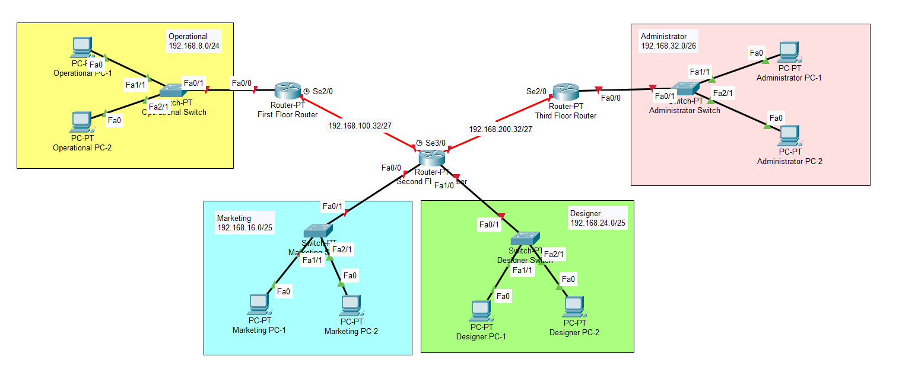

IP Configuration

* 1. Operational 192.168.8.0/24

PC-1 : 192.168.8.2

PC-2 : 192.168.8.3

Subnet : 255.255.255.0

Gateway : 192.168.8.1

* 1. Marketing 192.168.16.0/25

PC-1 : 192.168.16.2

PC-2 : 192.168.16.3

Subnet : 255.255.255.128

Gateway : 192.168.16.1

* 1. Designer 192.168.24.0/25

PC-1 : 192.168.24.2

PC-2 : 192.168.24.3

Subnet : 255.255.255.128

Gateway : 192.168.24.1

* 1. Administrator 192.168.32.0/26

PC-1 : 192.168.32.2

PC-2 : 192.168.32.3

Subnet : 255.255.255.192

Gateway : 192.168.32.1

* 1. First Floor Router

Se2/0 : 192.168.100.33

Fa0/0 : 192.168.8.1

* 1. Second Floor Router

Se2/0 : 192.168.100.34

Se3/0 : 192.168.200.34

Fa0/0 : 192.168.16.1

Fa1/0 : 192.168.24.1

* 1. Third Floor Router

Se2/0 : 192.168.200.33

Fa0/0 : 192.168.32.1

(EIGRP)

This Topology shows the LAN which is requested by Quantum & Clock.

You are asked to:

1. Assign IP address for every device
2. Connect each network using **EIGRP** with following criteria:

- Use **20** as the Autonomous system number of EIGRP

1. Make sure that every device is connected to each other

Rules that need to be satisfied:

1. IP assigned to connect 2 routers is determined based on router position (left to right):

- First usable IP address of the network is used for the first router (leftmost)  
- Second usable IP address of the network is used for the second router (rightmost)  
Example: if the network is 192.168.12.0/24, then:  
- IP address for the first router is 192.168.12.1  
- IP address for the second router is 192.168.12.2

1. IP assigned to the host is depends on the PC's name, for example:

- PC/Laptop-1 always use the second usable IP in the subnet  
- PC/Laptop-2 always use the third usable IP in the subnet  
- ...  
- PC/Laptop-Last always use the last usable IP in the subnet

First floor configuration

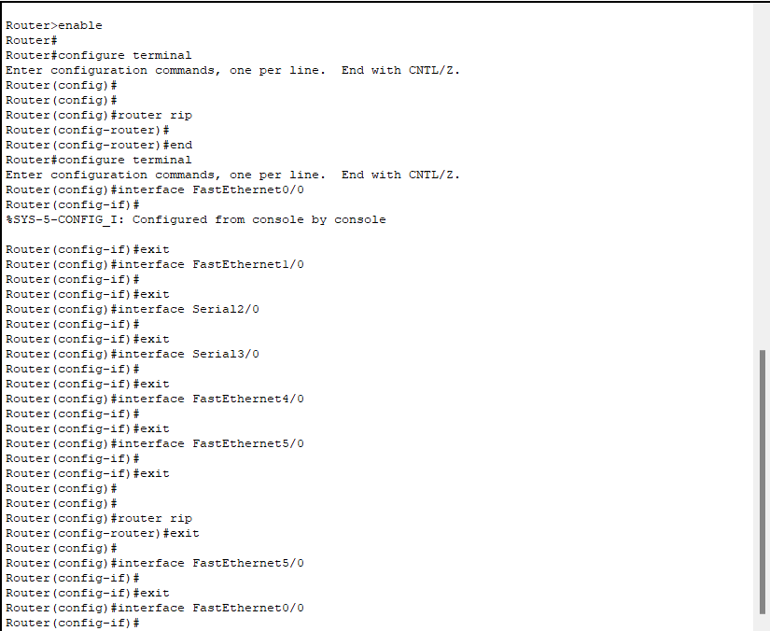

Second floor configuration

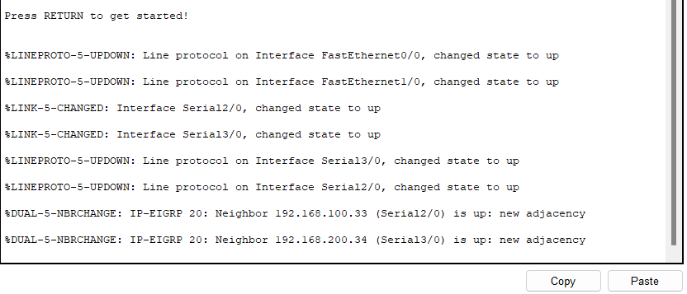

Third floor configuration

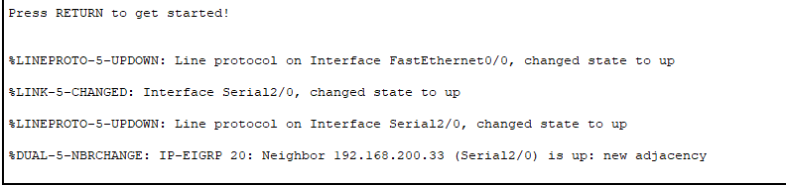

(OSPF)

This Topology shows the LAN which is requested by Quantum & Clock.

You are asked to:

1. Assign IP address for every device
2. Connect each network using **OSPF** with following criteria:

- Use process id **20**  
- Use area **10**

Rules that need to be satisfied:

* 1. IP assigned to connect 2 routers is determined based on router position (left to right):

- First usable IP address of the network is used for the first router (leftmost)  
- Second usable IP address of the network is used for the second router (rightmost)  
Example: if the network is 192.168.12.0/24, then:  
- IP address for the first router is 192.168.12.1  
- IP address for the second router is 192.168.12.2

* 1. IP assigned to the host is depends on the PC's name, for example:

- PC/Laptop-1 always use the second usable IP in the subnet  
- PC/Laptop-2 always use the third usable IP in the subnet  
- ...  
- PC/Laptop-Last always use the last usable IP in the subnet

First floor configuration

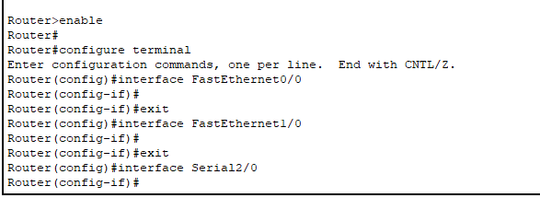

Second floor configuration

Third floor configuration

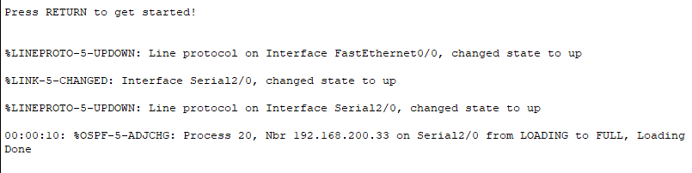

(RIP)

This Topology shows the LAN which is requested by Quantum & Clock.

You are asked to:

1. Assign IP address for every device
2. Connect each network using **RIP**
3. Make sure that every device is connected to each other

Rules that need to be satisfied:

1. IP assigned to connect 2 routers is determined based on router position (left to right):

- First usable IP address of the network is used for the first router (leftmost)  
- Second usable IP address of the network is used for the second router (rightmost)  
Example: if the network is 192.168.12.0/24, then:  
- IP address for the first router is 192.168.12.1  
- IP address for the second router is 192.168.12.2

1. IP assigned to the host is depends on the PC's name, for example:

- PC/Laptop-1 always use the second usable IP in the subnet  
- PC/Laptop-2 always use the third usable IP in the subnet  
- ...  
- PC/Laptop-Last always use the last usable IP in the subnet

First floor configuration

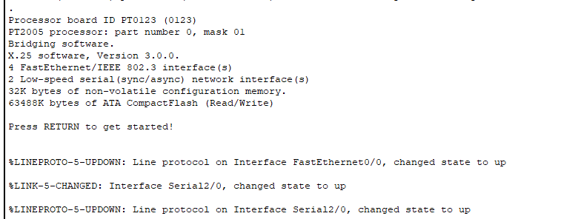

Second floor configuration

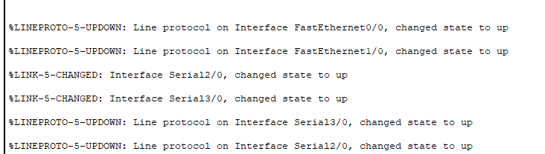

Third floor configuration

